**Artificial Intelligence Practical File**

**2021-2022**

**VI Semester**

**Name: Akanksha goel**

**Examination Roll No.: 19035570011**

**College Roll No.: 0726**

**Course.: B.Sc. (Hons) Computer Science**

**Section.: A**

**Q 8.Write a Prolog program to implement memb (X, L): to check whether X is a member of L or not.**

% X IS THE HEAD OF L

%X IS THE MEMBER OF TAIL OF L

member(X, [X|Tail]).

member(X, [Head|Tail]):- member(X, Tail).

member:-

write("Enter the List: "),

read(L),

write("Enter the number to be found: "),

read(X), write(X),

(member(X,L)-> write(" is the member of the given list") ;write("

is not the member of the given list")),!.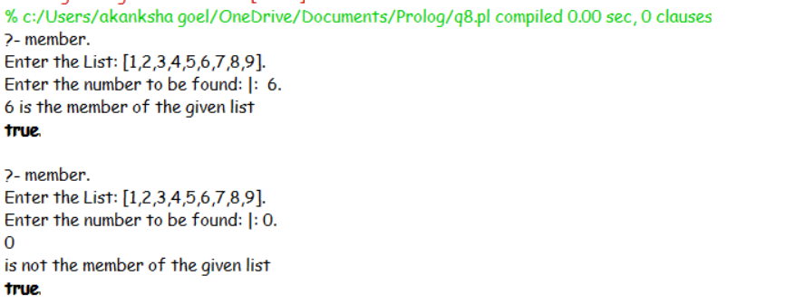

**Q9.Write a Prolog program to implement conc (L1, L2, L3) where L2 is the list to be appended with L1 to get the resulted list L3.**

conc([],L2,L3):- L3 = L2.

conc([X|L1],L2,[X|L3]):- conc(L1,L2,L3).

concatenate:-

write("Enter List One is : "),

read(L1),

write("Enter List two : "),

read(L2),

conc(L1,L2,L3),

write("The concatenated list is (L1,L2) is : "), write(L3),!.

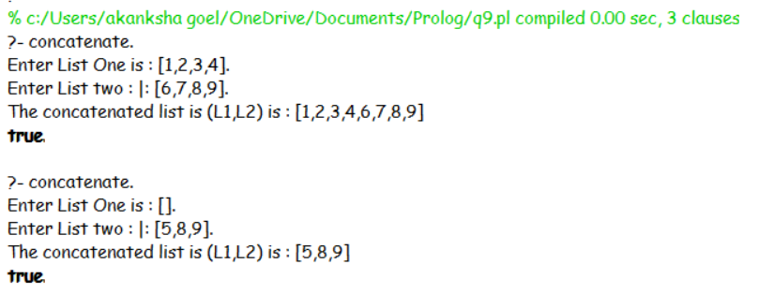

**Q 10. %Write a Prolog program to implement reverse (L, R) where List L is original and List R is reversed list.**

reverse(L1,R):- L1 =[] ,R = [].

reverse([X|L1],R):- reverse(L1,L3), conc(L3,[X],R).

reverse:-

write("Enter the list to be reversed :: "),

read(L1),

reverse(L1,L2),

write("Reversed list is :: "),

write(L2),!.

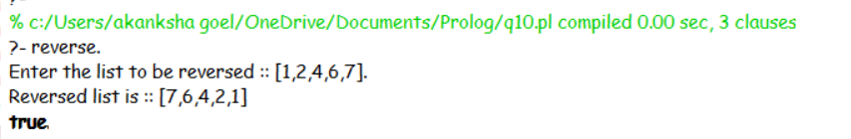

**Q11. %Write a program in PROLOG to implement palindrome (L) which checks whether a list L is a palindrome or not.**

palindrome(L):- reverse(L,L).

palindrome:-

write("Enter the list is : "),

read(L),

(reverse(L,L)->

write("The entered list is palindrome");

write("The entered list is not palindrome")),!.

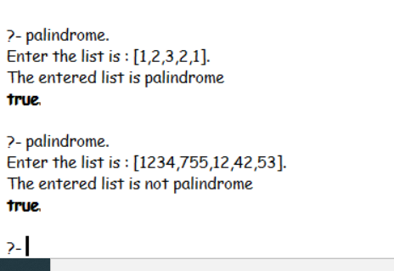

**Q 12. Write a Prolog program to implement sumlist(List,Sum) so that Sum is the sum of a given list of numbers List.**

sumlist(List,Sum):- List=[], Sum=0.

sumlist(List,Sum):- List=[Head|Tail], sumlist(Tail,SUM), Sum is

Head+SUM.

sumlist:-

write("Enter the list to sum : "),

read(List),

sumlist(List,Sum),

write("The sum of each element of list is: "),

write(Sum),!.

